Guided Capstone Project Report

Big Mountain Resort is a ski resort located in Montana offering spectacular views of Glacier National Park and Flathead National Forest, with access to 105 trails. The problem is what solutions Big Mountain needs to focus on to adjust their ticket price as part of their new business strategy in the next 5 years. After collecting and analyzing the data from other resorts in the market share, we see that the location of Big Mountain is already an advantage for attracting skiers. We look at the skiable terrain area, area covered by snow and vertical drop. Big Mountain also has the longest run length distribution.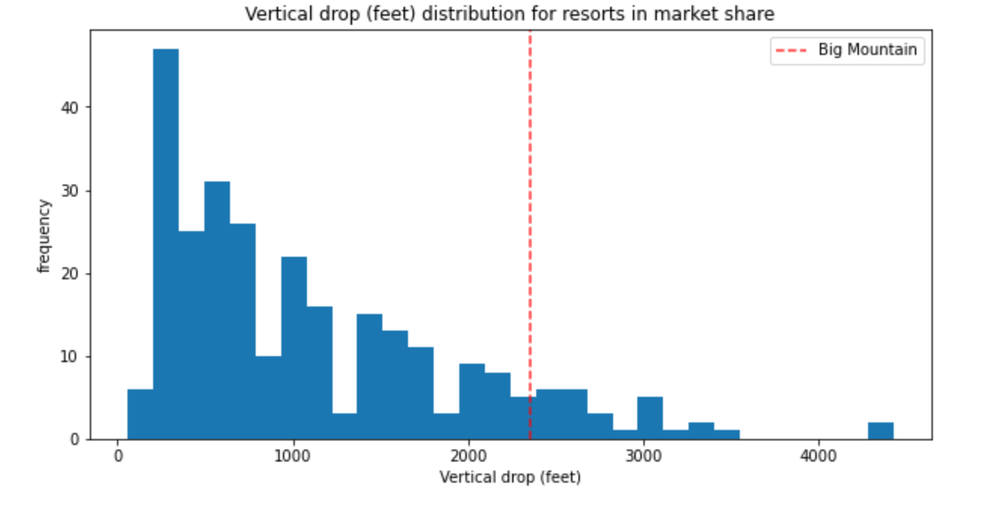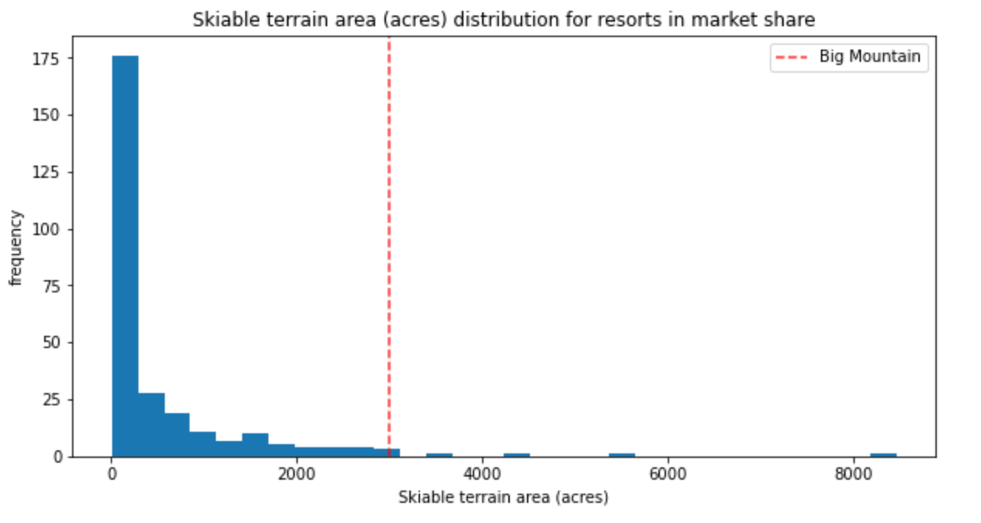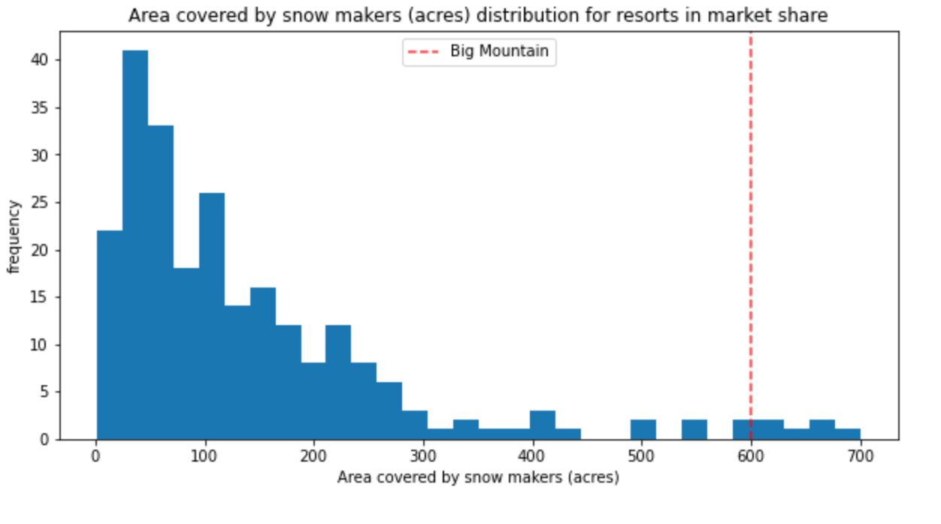

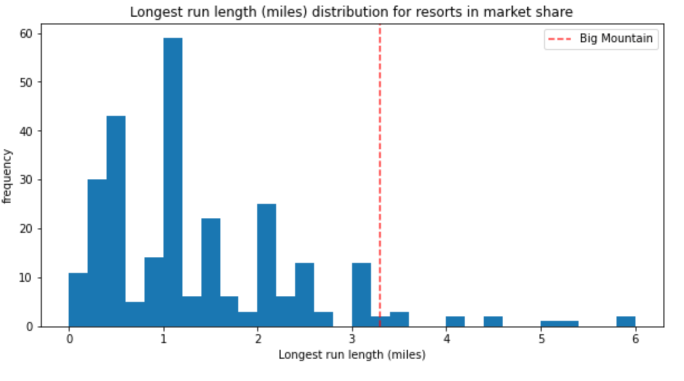

All the data above shows that Big Mountain does not need to spend more on installation of additional chairs to bring more skiers to the mountain. For right now, when we look at the data of adult weekend ticket prices of resorts in Montana state, Big Mountain is already charging their customers the most. Compared to the other resorts in the market, Big Mountain ticket prices are a little bit higher than those in Alaska.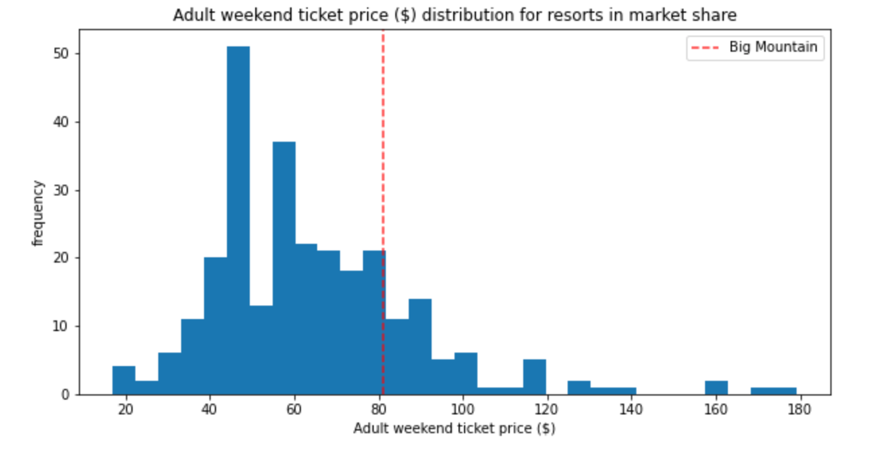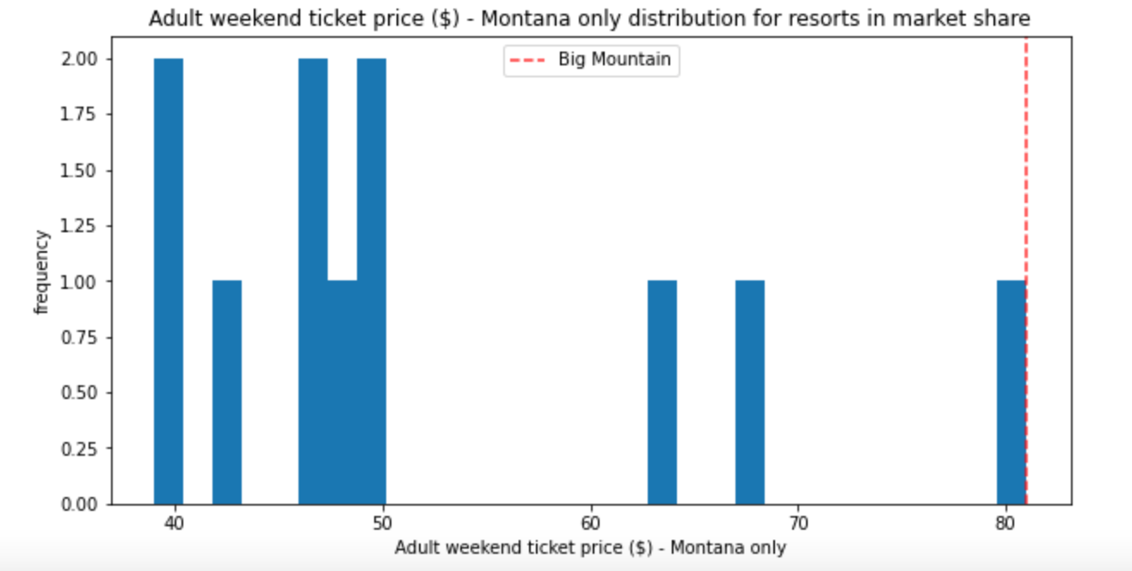

Therefore, the new business strategy of Big Mountain should consider keeping the average ticket price in the market segment. They should not install more equipment so they can cut down on spending for maintenance.

